Here’s what I understood from studying this task. I divided the following into phases to better understand and document my learnings.
Phrase 1: Installation & Setup
- Download a Linux VM on Windows
- Open it using software like Oracle VirtualBox or VMware etc
- Allocate at least 4GB RAM with a 20GB virtual hard disk.
- Set the network to NAT to share the host’s IP

Phase 2: Access Control & Permissions
- Explore User Accounts
  - View all users:
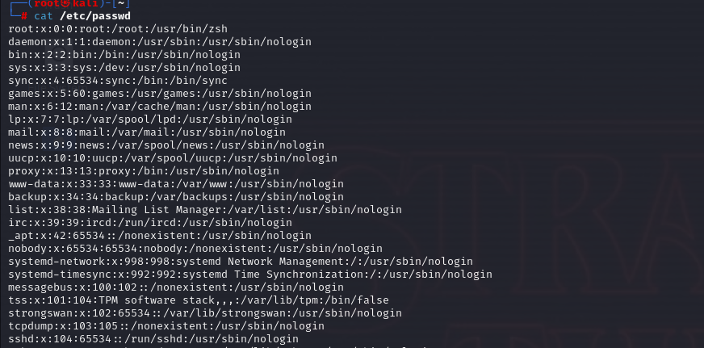
  - View Password Hashes:
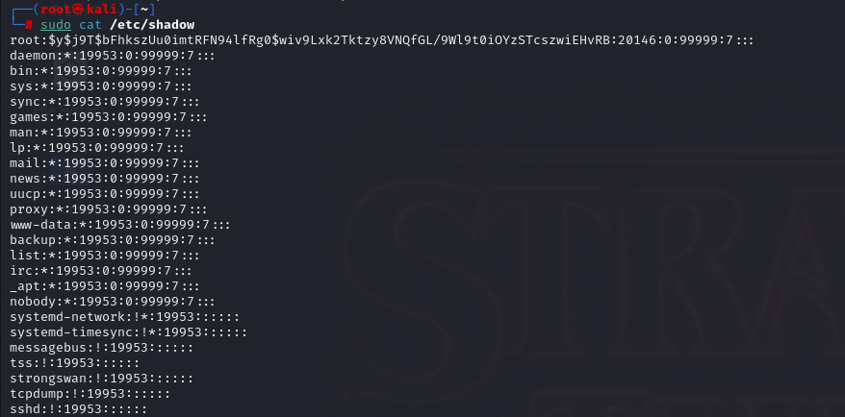
- Learn File Permissions
  - Command ls -l: gives a formatted list.
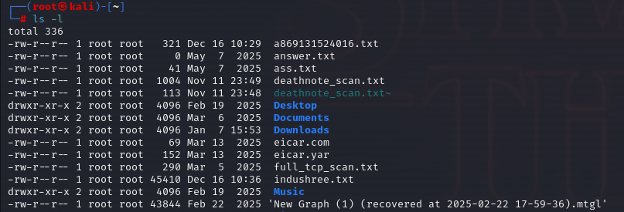
    - Output Breakdown: (drw-r—r-- )
      - Type: d = directory, - = file
      - User (Owner): rwx (Read, Write, Execute )
      - Group: r-x ( Read, Execute, No Write )
      - Others (World): r—(Read only)
    - Change Owner (chown)
    - Change Mode (chmod)
- Admin Vs Standard Privileges
  - Root: The “God mode” account. Has ID 0
  - Sudoers: Standard users who can temporarily become root.
  - Security Action: Create a “dummy” standard user for daily tasks to avoid accidental system damage.
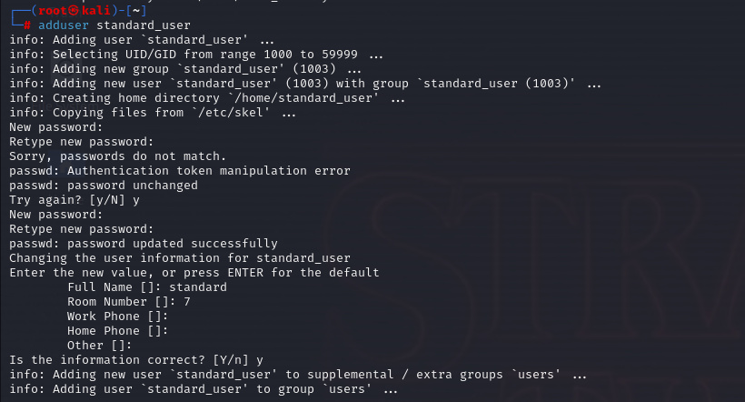
Phase 3: Network & Attack Surface Reduction
- Enable Firewall
  - Check Status:
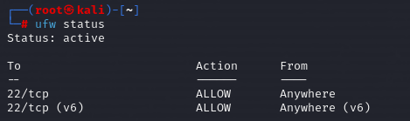
- Identify Processes & Services
  - View Running Processes:
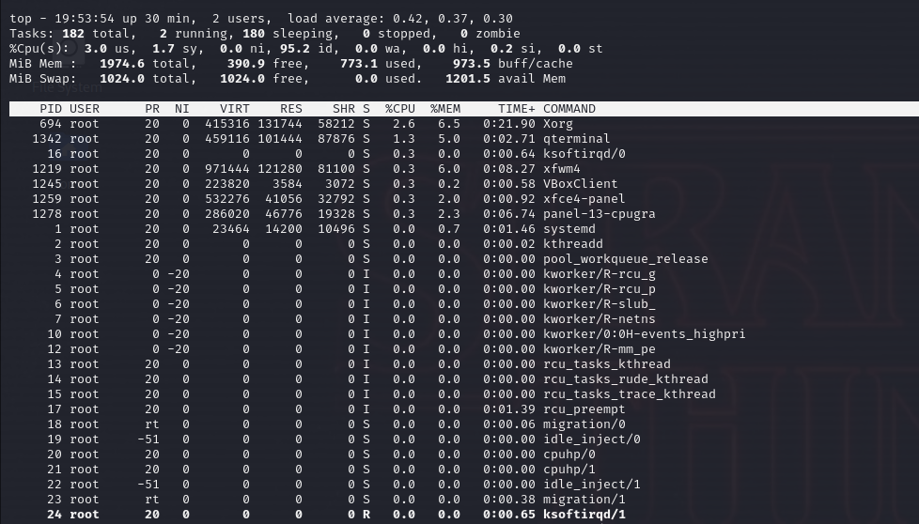
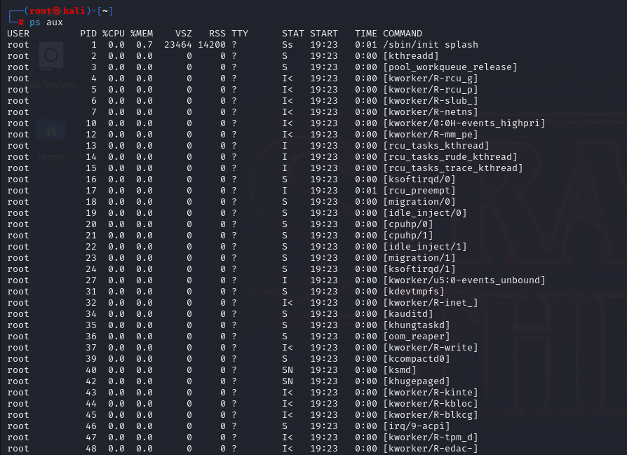
  - View Listening Ports :
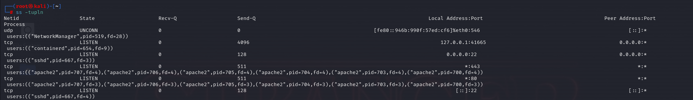
- Disable Unnecessary Services
  - List of Services:
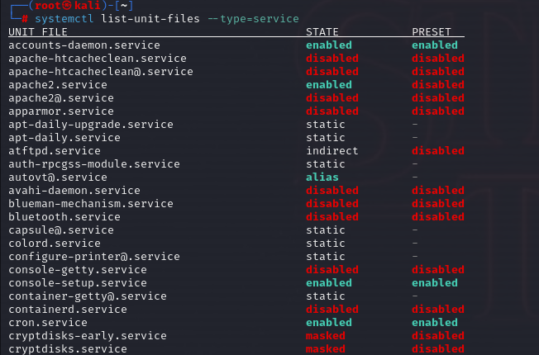
  - Disable a Service:
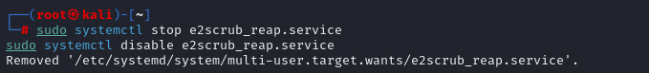
Phase 4: Documentation
- Access:
  - Create a non-root user for daily operations
  - Enforce strong password
  - Lock the root account password
- Files:
  - Audit files with 777 permissions
  - Ensure /etc/shadow is owned by root.
- Network:
  - Enable UFW Firewall
  - Block all incoming traffic by default.
  - Close unused ports
- Maintenance
  - Disable unused services

